Smart Home Security System
Student Name: Nive
Register Number:U03ZW24S0091
Class: B.Sc. 5th Semester MEC
Team Members: Yashaswini NS and Mariya Shobha A
1. Project Title
Smart Home Security System using ESP32, PIR Motion Sensor and ThingSpeak
2. Problem Statement
Monitoring a home manually for unwanted movement can be difficult. This project provides an IoT-based security solution using a PIR motion sensor connected to an ESP32.
The PIR sensor detects movement in the surroundings and sends the signal to the ESP32. When motion is detected, the ESP32 turns ON an LED as an indication. The motion data can also be monitored using the ThingSpeak cloud platform.
3. Objectives
- To detect motion using a PIR motion sensor.
- To interface the PIR sensor with ESP32.
- To process the motion signal using the ESP32.
- To turn ON the LED when motion is detected.
- To monitor motion status using ThingSpeak.
- To understand the basic working of an IoT-based security system.
- To simulate the project using Wokwi.
4. Components and Software Used
Hardware:
- ESP32
- PIR Motion Sensor
- LED
- Connecting wires
Software/Platforms:
- Wokwi Simulator
- Arduino IDE / Arduino C++
- ThingSpeak Cloud Platform
- GitHub

5. Circuit Diagram Connections
Component | ESP32 Pin | Connection
PIR VCC | 5V/VIN | Power
PIR OUT | GPIO 19 | Motion Signal
PIR GND | GND | Ground
LED | GPIO 5 | Output
LED GND | GND | Ground
The circuit diagram showing the connections between the ESP32, PIR motion sensor and LED is shown below.
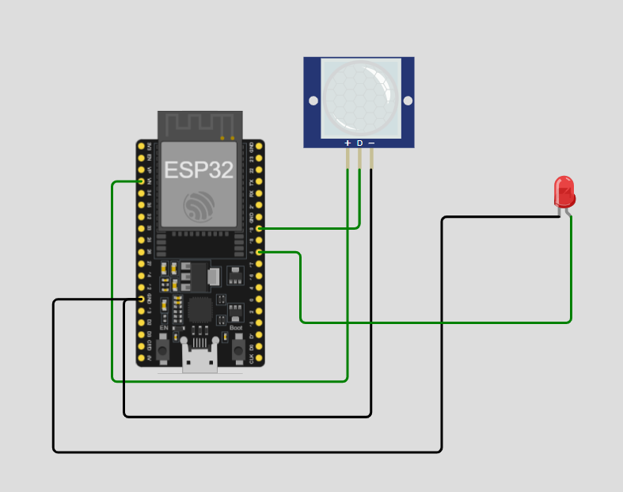
6. Block Diagram
The block diagram of the proposed IoT-based smart home security system is shown below.
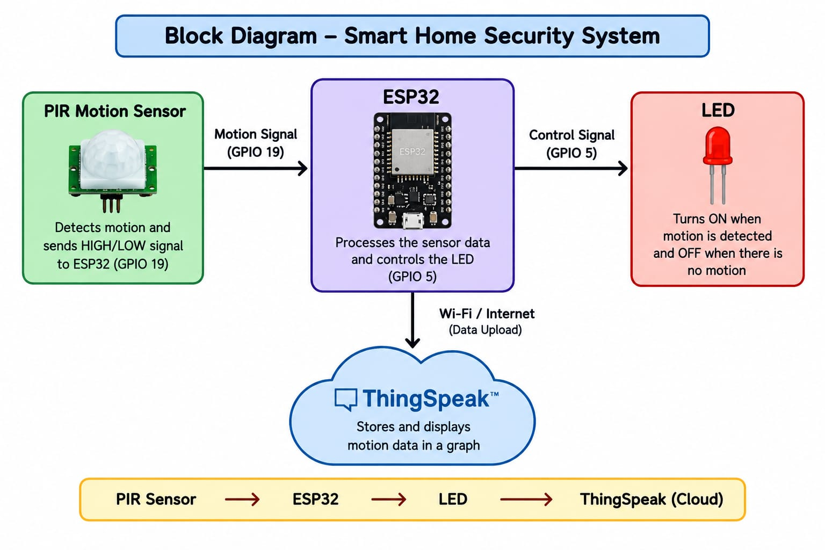
PIR Motion Sensor → ESP32 → LED
ESP32 → Wi-Fi → ThingSpeak Cloud
The PIR sensor detects motion and sends the signal to the ESP32. The ESP32 processes the signal and controls the LED. The motion status can also be monitored using ThingSpeak.

7. Working Principle
The PIR motion sensor detects movement in the surrounding area.
The PIR sensor is connected to GPIO 19 of the ESP32. When motion is detected, the sensor sends a HIGH signal to the ESP32.
The ESP32 reads this signal and turns ON the LED connected to GPIO 5. It also displays the message "Motion detected!" in the Serial Monitor.
When there is no motion, the PIR sensor sends a LOW signal. The ESP32 then turns OFF the LED and displays "Motion ended!".
The motion status can also be monitored using the ThingSpeak cloud platform, where the motion values can be represented as 0 and 1.

8. Program Code
const int ledpin = 5;
const int PIRinput = 19;
int pirState = LOW;
int val = 0;
void setup()
{
pinMode(ledpin, OUTPUT);
pinMode(PIRinput, INPUT);
Serial.begin(9600);
}
void loop()
{
val = digitalRead(PIRinput);
if (val == HIGH)
{
digitalWrite(ledpin, HIGH);
if (pirState == LOW)
{
Serial.println("Motion detected!");
pirState = HIGH;
}
}
else
{
digitalWrite(ledpin, LOW);
if (pirState == HIGH)
{
Serial.println("Motion ended!");
pirState = LOW;
}
}
delay(100);
}
Program Explanation
The program uses Arduino C++ to control the ESP32, PIR sensor and LED.
Important parts of the program include:
- const int ledpin = 5 – assigns GPIO 5 to the LED.
- const int PIRinput = 19 – assigns GPIO 19 to the PIR sensor.
- pinMode(ledpin, OUTPUT) – sets the LED pin as an output.
- pinMode(PIRinput, INPUT) – sets the PIR pin as an input.
- digitalRead(PIRinput) – reads the motion signal from the PIR sensor.
- digitalWrite(ledpin, HIGH) – turns ON the LED.
- digitalWrite(ledpin, LOW) – turns OFF the LED.
- "Motion detected!" – is displayed when motion is detected.
- "Motion ended!" – is displayed when motion is no longer detected.
- pirState is used to keep track of the previous motion state.

9. Output
The ESP32 successfully detects motion using the PIR sensor.
When motion is detected:
- The PIR sensor gives a HIGH signal.
- The ESP32 detects the signal.
- The LED turns ON.
- "Motion detected!" is displayed in the Serial Monitor.
When motion stops:
- The PIR sensor gives a LOW signal.
- The LED turns OFF.
- "Motion ended!" is displayed.
The motion status is also monitored using ThingSpeak and represented using a graph.
Wokwi Output Screenshot
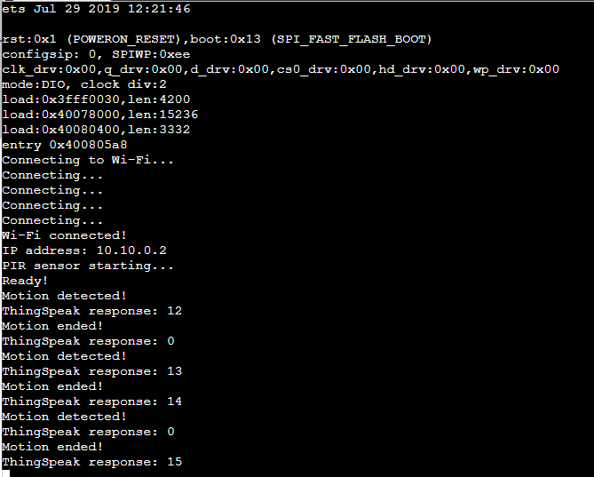
ThingSpeak Graph Screenshot
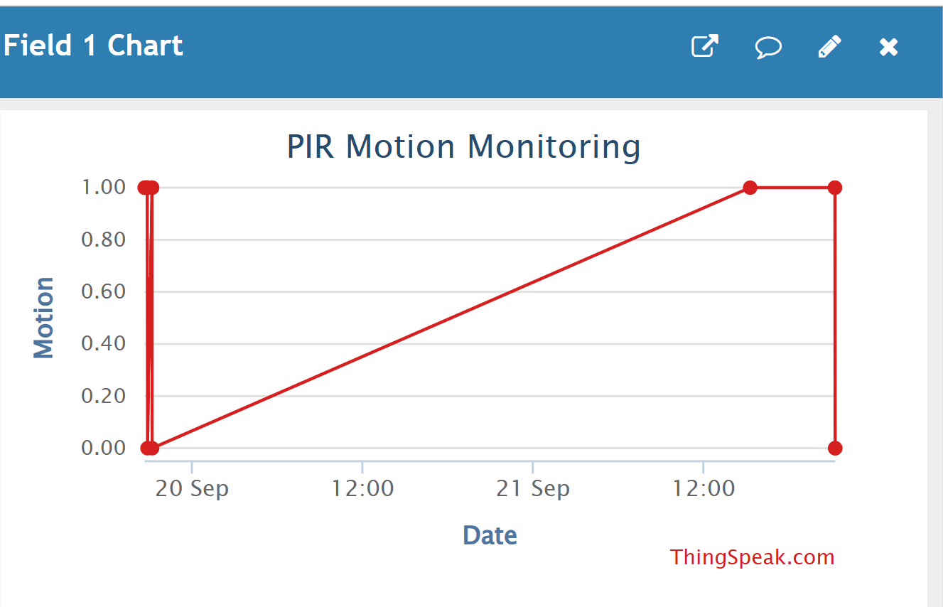
10. Applications
- Smart home security systems
- Motion detection systems
- Automatic lighting systems
- Room and entrance monitoring
- Intrusion detection
- Office security systems
- IoT-based security projects
- Educational IoT projects

11. Limitations
- The system requires a power supply for continuous operation.
- PIR sensors can sometimes detect unwanted movement.
- The detection range depends on the PIR sensor.
- Wi-Fi connectivity is required for cloud-based monitoring.
- The system only detects motion and does not identify the person.

12. Future Scope
The project can be improved by:
- Adding a buzzer for an alarm when motion is detected.
- Adding a camera for capturing images.
- Adding mobile notifications and alerts.
- Using a mobile application for monitoring.
- Adding more sensors for complete home security.
- Storing and analyzing larger amounts of motion data.
- Adding automatic door or light control.
- Developing a complete smart-home security system.

13. Team Members' Details
NAME | REGISTER NUMBER
Niveditha K | U03ZW24S0091
Yashaswini NS | U03ZW24S0094
MariyaShobha A | U03ZW24S0090

14. Wokwi Project Link
Wokwi Project:
https://wokwi.com/projects/475605312743188481

15. ThingSpeak Channel Link
ThingSpeak Channel:
https://thingspeak.mathworks.com/channels/3500296/private_show
16. Learning Reflection
Through this project, I learned how an IoT-based security system can detect motion using a PIR sensor and ESP32.
I learned how to connect a PIR motion sensor with the ESP32 and control an LED based on the detected motion. I also learned how to write a program using Arduino C++ and simulate the circuit using Wokwi.
I gained knowledge about monitoring sensor data using ThingSpeak and understood how IoT devices can be connected with cloud platforms. This project helped me understand the practical working of sensors, microcontrollers, cloud platforms and IoT communication.
Conclusion
This project successfully demonstrates an IoT-based Smart Home Security System using ESP32 and a PIR motion sensor. The PIR sensor detects movement and sends the signal to the ESP32. The ESP32 processes the signal and controls the LED as an indication of motion.
The motion status can also be monitored using ThingSpeak. Through this project, we gained practical knowledge about ESP32, PIR sensors, LED control, Wokwi simulation, ThingSpeak and IoT-based security systems.

